Monday | Tuesday | Wednesday | Thursday | Friday
1  Happy New Year!  Center Closed | 2  AM Goldfish & Water  Breakfast Rice Cakes & Apple Slices  PM Pretzels & Apple Juice | 3  AM Rice Cakes & Milk  Breakfast French Toast & Bananas  PM Cucumbers w/ Saltines & Water | 4  AM Orange Slices & Milk  Breakfast Life Cereal & Oranges Slices  PM Goldfish Grahams & Milk | 5  AM Teddy Grahams & Milk  Breakfast Waffles & Strawberries  PM Carrots w/Wheat Thins & Water
8  AM Graham Crackers & Milk  Breakfast Corn Chex & Oranges slices  PM Yogurt w/Blueberries & Water | 9  AM Goldfish & Milk  Breakfast Pancakes & Canned Pineapple  PM Animal crackers & Water | 10  AM Rice Cakes & Milk  Breakfast Oatmeal & Apple Slices  PM Cucumbers w/ saltine crackers & Orange Juice | 11  AM Canned Peaches & Milk  Breakfast Cinnamon Toast & Canned Mandarin Oranges  PM Broccoli w/ ranch and pita chips & Milk | 12  AM Wheat Thins w/ Raisins & Water  Breakfast Cheerios & Canned Fruit Cocktail  PM Trail mix & Water
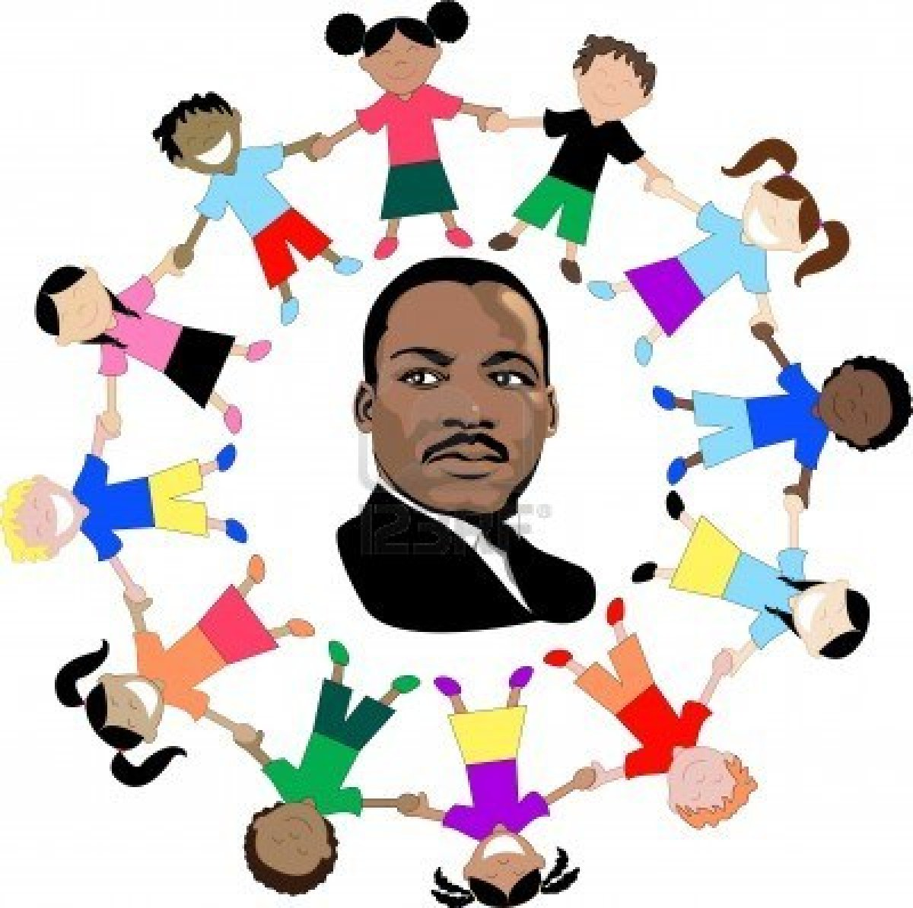  15  Dr. Martin Luther King Jr.’s Birthday: Schools Closed | 16  AM Cheese-Its & Milk  Breakfast Kix Cereal & Canned Pears  PM Green peppers w/ string cheese & Water | 17  AM Apple Slices w/ Wheat Thins & Water  Breakfast Bagels & Applesauce  PM Carrots w/ranch, wheat thins & Milk | 18  AM Canned Pears & Milk  Breakfast Special K & Canned Pears  PM Pudding w/Teddy Grahams & Water | 19  AM Goldfish & Apple Juice  Breakfast Waffles & Canned Pineapples  PM Cucumber w/ranch, Triscuits & Grape juice
22  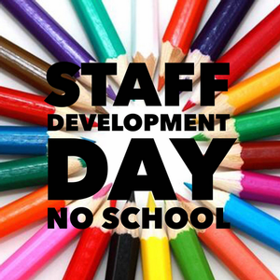 | 23  AM Oranges w/ Saltines & Water  Breakfast Cinnamon Toast & Canned Pears  PM Tortilla chips w/salsa & Milk | 24  AM Apples w/dried Cranberries & Water  Breakfast French Toast & Bananas  PM Animal Crackers & Milk | 25  AM Veggie Straws & Milk  Breakfast Pancakes & Canned Peaches  PM Graham crackers & Milk | 26  AM Pretzels w/ Raisins & Water  Breakfast Bagel & Orange Slices  PM Cheez-Its & Pineapple Juice
29  AM String Cheese w /saltine Crackers & Water  Breakfast Life Cereal & Apples  PM Goldfish & Pineapple Juice | 30  AM Applesauce & Milk  Breakfast French Toast & Applesauce  PM Tortilla Chips w/ Salsa & Water | Early Childhood Training Program Child Care 2024 Menu  *Milk will always be served with every breakfast and lunch*

