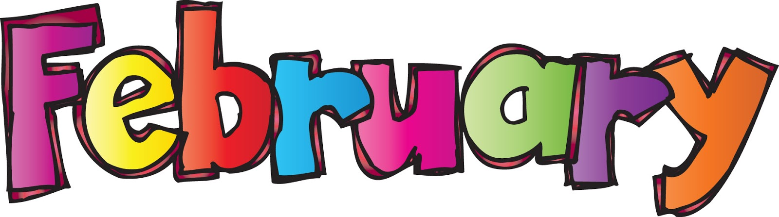
s
Monday |  | Tuesday |  | Wednesday | Thursday | Friday
 |  |  |  |  | 1  AM Orange Slices & Milk  Breakfast Bagels & Blueberries  Milk  PM Broccoli w/ Wheat Thins & Water | 2  AM Apple Slices & Milk  Breakfast Chex Cereal & Strawberries, Milk  PM Bug Grahams & Milk
5  AM Rice Cakes & Milk  Breakfast Oatmeal & Apple slices, Milk  PM Green Pepper w/ String Cheese &Water |  | 6  AM Goldfish & Water  Breakfast Waffle Sticks & Blueberries, Milk  PM Celery w/ Sun Butter & Milk |  | 7  AM Pretzels & Apple Juice  Breakfast Cheesy Toast & Canned Pears Milk  PM Yogurt w/ strawberries & Milk | 8  AM Canned Peaches & Milk  Breakfast Chex Cereal & Orange Slices, Milk  PM Cheez- Its w/ Dried Cranberries  & Water | 9  AM Saltines w/ Canned Pears & Water  Breakfast Pancakes & Applesauce  , Milk  PM Trail Mix & Grape juice
12  AM Veggie Straws & Milk  Breakfast French Toast & Canned Pears, Milk  PM Pudding w/ Vanilla Wafers & Water |  | 13  AM Animal crackers & Water  Breakfast Cheerios & Canned Fruit Cocktail, Milk  PM Animal Crackers & Milk | 14  AM Graham Crackers & Milk  Breakfast Oatmeal & Banana,  Milk  PM Broccoli, Saltines & Water |  | 15  AM Pretzels and Sun Butter & Water  Breakfast Bagels & Applesauce  PM Carrots w/ ranch & Saltine Crackers & Water | 16  AM Orange Slices & Milk  Breakfast Life Cereal & Canned Peaches, Milk  PM Rice Cakes & Apple juice
19  Presidents Day    Schools/offices Closed |  | 20  AM Saltines w/ Raisins & Milk  Breakfast Kix Cereal & Canned Pineapples, Milk  PM Applesauce w/ Graham Crackers & Water |  | 21  AM Saltine crackers, sliced cheese & Water  Breakfast Waffle Sticks & Canned Mandarin Oranges, Milk  PM Cucumbers w/ Wheat Thins & Water | 22  AM Apple Slices w/ Graham Crackers & Water  Breakfast Rice Chex & Apples slices, Milk  PM Bug Grahams & Milk | 23  AM Rice cakes & Milk  Breakfast Pancakes & Applesauce  Milk  PM Whole Grain Tortilla Chip w/Salsa & Milk
26  AM Pretzels & Milk  Breakfast Cheerios & Blueberries, Milk  PM Graham Crackers & Milk |  | 27  AM Rice Cakes & Milk  Breakfast Cinnamon Toast & Canned Fruit Cocktail, Milk  PM Broccoli w/ Wheat Thins & Water |  | 28  AM Cheez Its Raisins & Water  Breakfast Special K Cereal & Canned Peaches Milk  PM Nutri-Grain bar & Milk | 29  AM Orange Slices & Milk  Breakfast Bagels & Canned Mandarin Oranges, Milk  PM Carrots w/ranch, Saltines & Water | 1  AM Bug Grahams & Milk  Breakfast Life Cereal & Oranges  Milk  PM Animal Crackers & Milk

