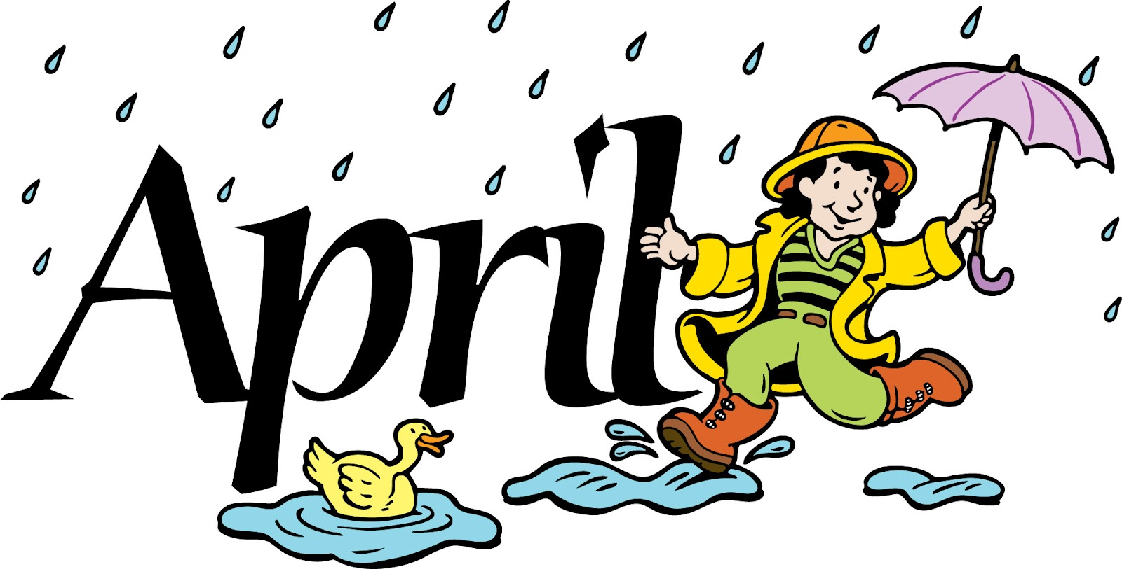
s
Monday | Tuesday |  | Wednesday | Thursday | Friday
 |  |  |  |  | 1  Trail Mix (Cereal, Raisins, Goldfish) w/ Orange Slices & Water
4  Whole Wheat Goldfish  & Apple Juice | 5  Carrots w/Saltines  & Water |  | 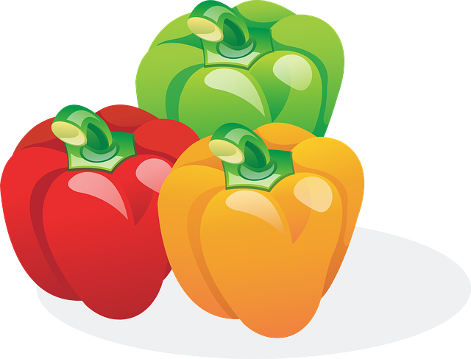 | 7  Celery w/ Cream Cheese, Dried Cranberries & Water | 8  Veggie Straws & Milk
11  Applesauce w/ Graham Crackers & Water | 12  Cucumbers w/Wheat Thins & Water | 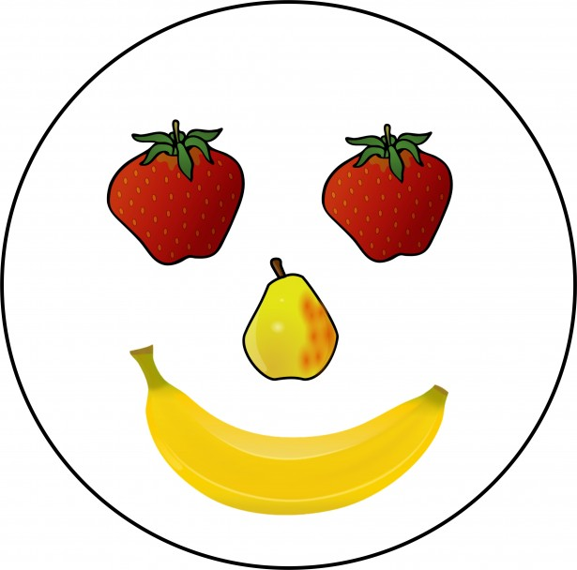 |  | 14  Broccoli w/Wheat Thins & Water | 15  Spring Break  Center Closed
18  Spring Break  Center Closed | 19  Spring Break  Center Closed |  | 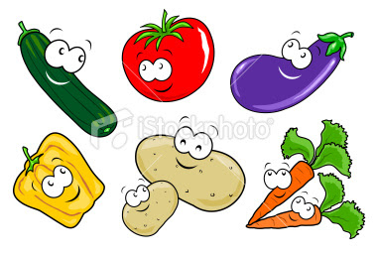 | 21  Spring Break  Center Closed | 22  Spring Break  Center Closed
25  Graham Crackers  & Milk | 26  Pretzels & Apple Juice |  |  | May 2  Orange Peppers w/ String Cheese  & Water | 29  Whole Grain Tortilla Chip w/Salsa & Milk

