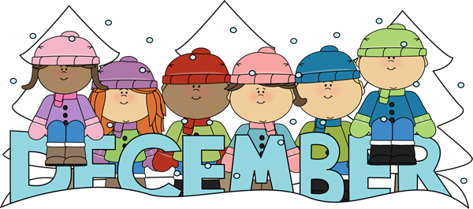
s
Monday | Tuesday | Wednesday | Thursday | Friday
 |  |  | 2  Pineapple  & Milk | 3  Broccoli w/ Wheat Saltines & Water
6  Pretzels w/Cheese  & Water | 7  Celery w/Cream Cheese and Dried Cranberries  & Water |  | 9  Graham Crackers  & Milk | 10  Whole Grain Tortilla Chips w/Salsa  & Milk
13  Animal Crackers  & Milk | 14  Carrot  w/ Triscuits  & Water |  | 16  Mandarin Oranges  & Milk | 17  Goldfish  &  Apple Juice
20  Rice Cakes & Milk | 21  Cheese w/Apples Slices & Water |  |   Center Closed  December 23- January 1

